In This Issue
Welcome to the first issue of our newsletter. You’ll find articles on a wide variety of topics.

Rally the Readers!
Tips from the Teacher
Powerful Performances
Technology Time
Class Calendar

Rally the Readers!
Reading is a critical skill in everything we do. In this column, students talk about their reading experiences.

This is where more information will go. This is where more information will go. This is where more information will go. This is where more information will go. This is where more information will go. This is where more information will go. This is where more information will go. This is where more information will go. This is where more information will go. This is where more information will go. This is where more information will go.

Tips from the Teacher
Lots of exciting things are happening in our classroom.

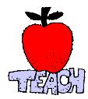
This is where more information will go. This is where more information will go. This is where more information will go. This is where more information will go. This is where more information will go. This is where more information will go. This is where more information will go.

Powerful Performances
Our students are doing great things in our classroom. Here are some examples.


This is where more information will go. This is where more information will go. This is where more information will go. This is where more information will go. This is where more information will go. This is where more information will go. This is where more information will go. This is where more information will go. This is where more information will go. This is where more information will go. This is where more information will go. This is where more information will go. This is where more information will go. This is where more information will go. This is where more information will go.

Technology Time
Students love using computers and other technology. Let’s explore some things you can do at home that promote learning.
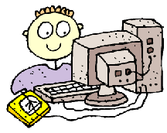
This is where more information will go. This is where more information will go. This is where more information will go. This is where more information will go. This is where more information will go. This is where more information will go. This is where more information will go. This is where more information will go. This is where more information will go. This is where more information will go. This is where more information will go. This is where more information will go. This is where more information will go. This is where more information will go. This is where more information will go.

Class Calendar
Lots of exciting things are happening in our classroom. Keep track with the following schedule of events.

Date Event or topic
Date Event or topic
Date Event or topic
Date Event or topic
Date Event or topic
Date Event or topic
Date Event or topic
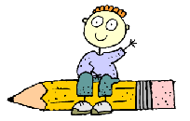

About Us

This newsletter was produced by students in BLANK class at BLANK school.
Our School
School Address
School Phone
Class Email

This is where you might include a publication policy.

