In This Issue
You’ll find lots of interesting articles on the habitats of birds.

Penguins on the Beach
Owl in the Tree
Parrots of the Jungle
Flamingos of the Wetlands
Map of the Birds

Penguins on the Beach
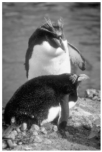
Look for penguins on the beach.

This is where more information will go. This is where more information will go. This is where more information will go. This is where more information will go. This is where more information will go. This is where more information will go. This is where more information will go. This is where more information will go. This is where more information will go. This is where more information will go. This is where more information will go.

The Owl in the Tree
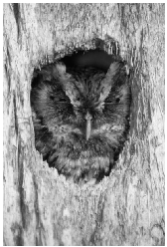
Owls look for cozy trees to make their home.

This is where more information will go. This is where more information will go. This is where more information will go. This is where more information will go. This is where more information will go. This is where more information will go. This is where more information will go.

Parrots of the Jungle
You’ll find parrots in warm jungles.

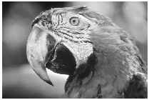
This is where more information will go. This is where more information will go. This is where more information will go. This is where more information will go. This is where more information will go. This is where more information will go. This is where more information will go. This is where more information will go. This is where more information will go.

Flamingos of the Wetlands
You’ll find plastic flamingos in front yards, but real flamingos are found in the wetlands.

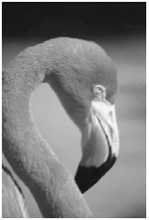
This is where more information will go. This is where more information will go. This is there more information will go. This is where more information will go. This is where more information will go. This is where more information will go. This is where more information will go. This is where more information will go. This is where more information will go. This is where more information will go. This is where more information will go. This is where more information will go. This is where more information will go. This is where more information will go. This is where more information will go.

Map the Birds
Let’s look at a map showing where our birds are found!
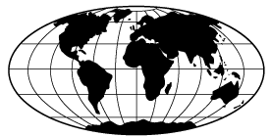

About Us

This newsletter was produced by students in BLANK class at BLANK school.

Our School
School Address
School Phone
Class Email

This is where you might include a publication policy.

