In This Issue
You’ll find lots of interesting articles about how life has changed from the 1920-50s and Now

Outhouse or Bathroom?
Stove or Microwave?
Radio or Television?
Crank Phone or Cell Phone?
Model T or SUV?

Outhouse or Bathroom?
Then - We didn’t have an indoor toilet. We had to go to a small shack in the back yard called an outhouse.
Now – We have lots of bathrooms in our house.

The photo from the Library of Congress was taken in 1949.

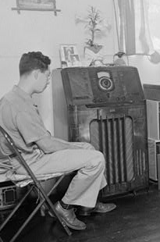
This is where more information will go. This is where more information will go. This is where more information will go. This is where more information will go. This is where more information will go. This is where more information will go. This is wher
e more information will go. This is where more information will go. This is where more information will go. This is where more

Stove or Microwave?
Then – We used a gas stove. We had to use a match to light the stove.
Now – We heat things in a microwave.

The photo from the Library of Congress was taken in 1910.

This is where more information will go. This is where more information will go. This is where more information will go. This is where more information will go. This is where more information will go. This is where more information will go. This is where more information will go. This is where more information will go.

Radio or Television
Then – We listened to radio programs in the evening. We had one radio in the living room and no televisions.
Now – We have a television in almost every room in our house. We have cable television and zillions of channels.

The photo from the Library of Congress was taken in 1943.

This is where more information will go. This is where more information will go. This is where more information will go. This is where more information will go. This is where more information will go. This is where more information will go. This is where more information will go. This is where more information will go. This is where more information will go. This is where more information will go. This is where more information will go. This is where more information will go. This is where more information will go. This is where more information will go. This is where more information will go.

Crank Phone or Cell Phone?
Then – We had one phone and it’s phone number was a “long” and a “short”.
Now – Today we have 3 phones in the house and a cell phone.

The photo from the Library of Congress was taken in 1920.

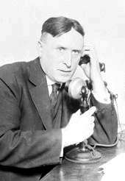

This is where more information will go. This is where more information will go. This is where more information will go. This is where more information will go.

Model T or SUV?
Then – Most of the cars were black and they were called things like Model T.
Now – Today lots of people drive bright colored cars and SUVs.

The photo from the Library of Congress was taken in 1913(?).

This is where more information will go. This is where more information will go. This is where more information will go. This is where more information will go. This is where more information will go. This is where more information will go.

Photo Credits
The photos came from the Library of Congress - http://memory.loc.gov/

About Us

This newsletter was produced by students in BLANK class at BLANK school.

Our School
School Address
School Phone
Class Email

This is where you might include a publication policy.

