Apex 5.1 “The Book As Knowledge”

By Elizabeth Fishero

S681: The History of Books

2013

Elizabeth Fishero

10/24/2013

**Apex 5.1. Build a Timeline**

**Timeline of First Books**

**Published by HarperCollins**

Visit this site to check out the Time Line created on Time Glider: <http://timeglider.com/timeline/3c84efaf5c5980e0>

**HarperCollins Publishers LLC** is one of the world's largest publishing companies. Headquartered in New York City, the company is a subsidiary of News Corp. The company name is a combination of Harper and Row - an American publishing company acquired in 1987, itself the result of an earlier merger of Harper and Brothers (founded 1817) and Row, Peterson & Company - and UK publishing company William Collins, Sons (founded 1819), acquired in 1990. The worldwide CEO of HarperCollins is Brian Murray. HarperCollins has publishing groups in the United States, Canada, the United Kingdom, Australia, New Zealand, and India. The company publishes many different imprints, both former independent publishing houses and new imprints.

HarperCollins maintains the backlist of many of the books originally published by their many merged imprints, in addition to having picked up new authors since the merger. Authors published originally by Harper include Mark Twain, the Bronte Sisters and William Makepeace Thackeray. Authors published originally by Collins include H.G. Wells, Agatha Christie, and J.R. Tolkien. This is a timeline of the very first books published by HarperCollins.

**1821: First book published is The Christian and Civic Economy of Large Towns**

Chalmers, Thomas. (1821). The Christian and Civic Economy of Large Towns. Glasgow: Chalmers and Collins. Retrieved from: <https://archive.org/details/christianandciv10chalgoog>

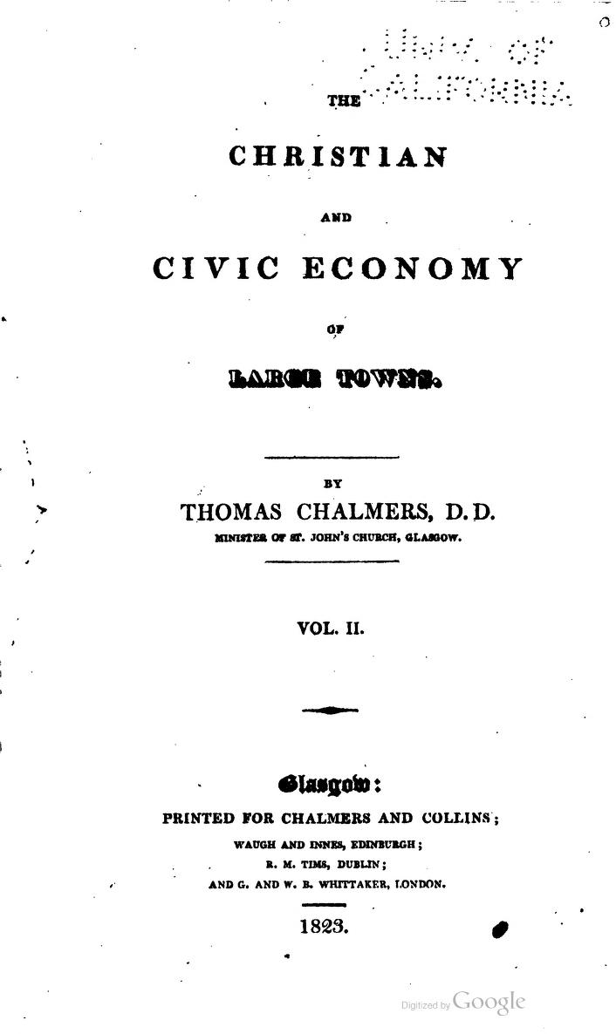

**1840: Begins publishing Illustrated Dictionaries.**

Hooper, Robert and Akerly, Samuel. (1832). “Lexicon medicum, or, Medical dictionary : containing an explanation of the terms in anatomy, botany, chemistry, materia medica, midwifery, mineralogy, pharmacy, physiology, practice of physic, surgery, and the various branches of natural philosophy connected with medicine : selected, arranged, and compiled from the best authors.” New York: Collins. Retrieved from: <https://archive.org/details/101526711.nlm.nih.gov>

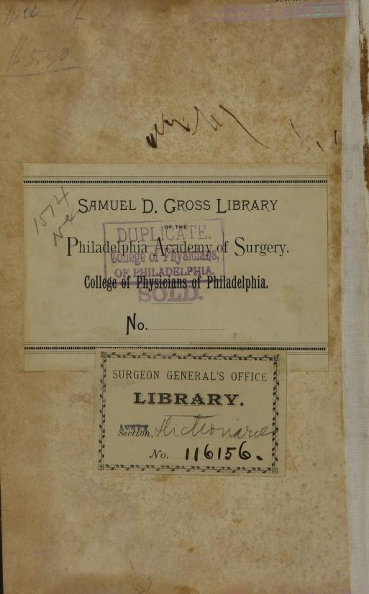

**1841: Obtains a license to print and publish the Bible.**

The Bible. (1876). New York: William Collins. Retrieved from: <https://archive.org/details/bibletextbookor00newy>

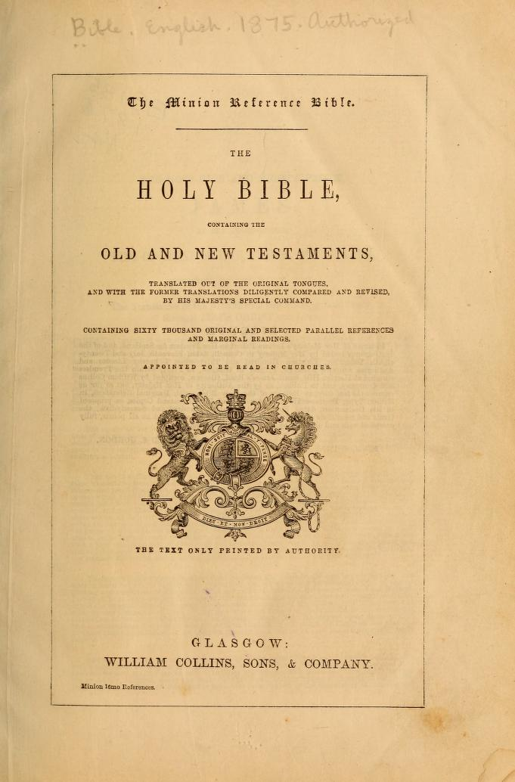

**1883: Publishes the first dictionary - Greek and English Lexicon.**

Liddell, Henry George. (1883). A Greek-English Lexicon. New York: Harper. Retrieved from: <https://archive.org/details/greekenglishlex00liddrich>

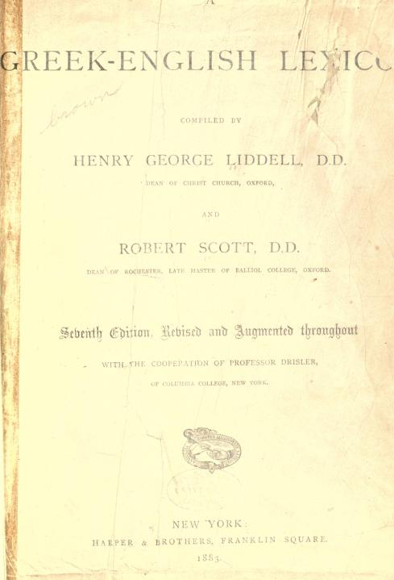

**1907: William II introduces new, up-to-date steam presses, publishes and prints the works of Shakespeare and Pilgrim’s Progress in cheap editions, making them available to the masses.**

Pilgrim’s Progress describes the story of Pilgrim, a person who travels in life trying to understand life and the meaning of life, and the significance of the people that he meets, what they want, and how they help him (or hinder him) from reaching the city he is trying to get to.

Bunyan, John. (1907). Grace abounding and the Pilgrim’s Progress. Cambridge: Collins. Retrieved from: <https://archive.org/details/graceaboundingpi01buny>

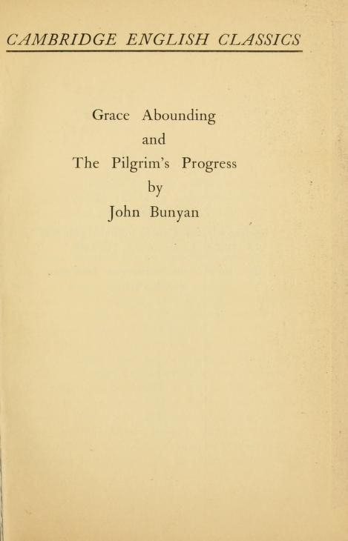

**1925: Publishes Agatha Christie’s first novel The Murder of Roger Ackroyd. The Crime Club list formed**

Christie, Agatha. (1925). The Murder of Roger Ackroyd. New York: HarperCollins. Retrieved from: <http://www.agathachristie.com/christies-work/stories/the-murder-of-roger-ackroyd/39>

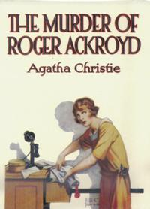

**Works Cited:**

Bunyan, John. (1907). Grace abounding and the Pilgrim’s Progress. Cambridge: Collins. Retrieved from: <https://archive.org/details/graceaboundingpi01buny>

Chalmers, Thomas. (1821). The Christian and Civic Economy of Large Towns. Glasgow: Chalmers and Collins. Retrieved from: <https://archive.org/details/christianandciv10chalgoog>

Christie, Agatha. (1925). The Murder of Roger Ackroyd. New York: HarperCollins. Retrieved from: <http://www.agathachristie.com/christies-work/stories/the-murder-of-roger-ackroyd/39>

“Harper Collins About Us.” Retrieved from: <http://www.harpercollins.co.uk/about-harpercollins/history/Pages/history.aspx>. October 24, 2013.

Hooper, Robert and Akerly, Samuel. (1832). “Lexicon medicum, or, Medical dictionary : containing an explanation of the terms in anatomy, botany, chemistry, materia medica, midwifery, mineralogy, pharmacy, physiology, practice of physic, surgery, and the various branches of natural philosophy connected with medicine : selected, arranged, and compiled from the best authors.” New York: Collins. Retrieved from: <https://archive.org/details/101526711.nlm.nih.gov>

Liddell, Henry George. (1883). A Greek-English Lexicon. New York: Harper. Retrieved from: <https://archive.org/details/greekenglishlex00liddrich>

The Bible. (1876). New York: William Collins. Retrieved from: <https://archive.org/details/bibletextbookor00newy>