Adapt an Activity:
Four Activities Evaluation

Step 1: Pick a colored card from the bag. Find the table with your matching card.

Step 2: Round one will be held at this table.

Step 3: The timer will be set for 10 minutes. At the end of 10 minutes you’ll rotate tables.

Step 4: Move to next round (repeat for 4 total rounds)

Step 5: Form a group of all unmatched cards. Discuss your results.

Simulation Activity:
“I’m Fine. Just Give Me a Band-aid” Role-play

Mission. Conduct an effective conversation with a reluctant patient.
Step 1: Divide the group in half. Move to opposite sides of the room.
Step 2: Members of Group A will take on the role of a reluctant patient and brainstorm a set of provocative statements, questions, or demands.
Example: “I’m late for a meeting and I don’t have time for this.”
Step 3: Members of Group B will take on the role of EMTs and brainstorm effective statements to defuse the situation and empathic reactions to provocative statements.
Example: “Sir, I’m sorry you feel that way. We can save time by….”
Step 4: Identify a member of the opposite team and conduct a one-on-one conversation between the patient and the EMT. A member of Group A will initiate the angry conversation by asking a question or making a demand. The person from Group B will respond in a calm and empathetic fashion to defuse the hostility. After one minute, the pairs will shift.
Step 5: After all Group A members have interacted with Group B members, take a couple minutes to create a character and switch roles. Conduct another set of rounds.

Step 6: Debrief.
What are techniques and statements that worked effectively to defuse or calm the patient?
What are examples of empathic, apologetic, reassuring, and limit-setting statements?
What is a piece of advice you’d give a new EMT?
Step 7: Discuss the use of role-playing as a teaching tool and design your own assignment.
Step 8: If you have time, try a round focusing on your own role-playing assignment.

Discussion Activity:
Infographics as Discussion Starters
Mission. Use an infographic as a starter for a discussion.
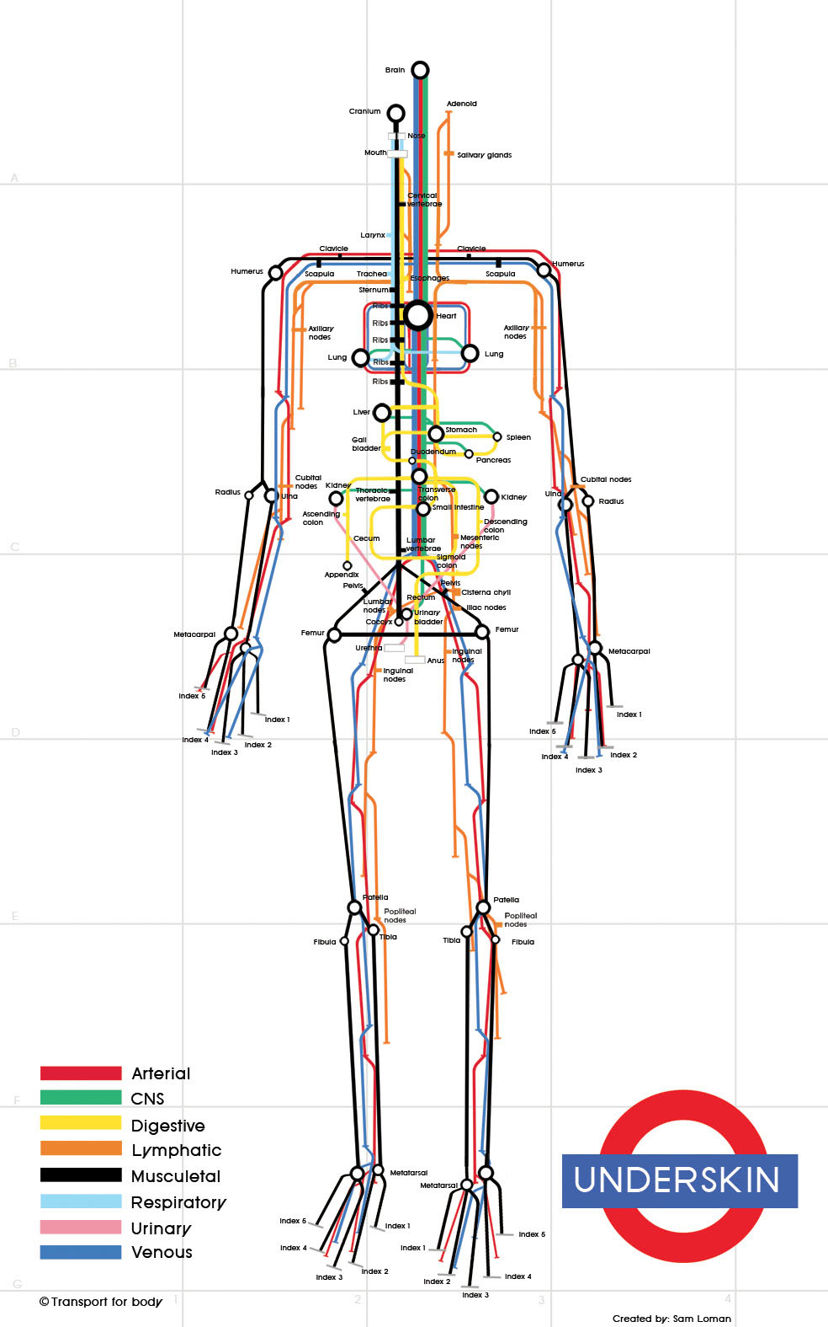
Step 1: Each member of the group should choose a different infographic. Take a couple minutes to think about the questions below that match your infographic:
- Human Subway - Is this graphic correct? Trace each system. Is anything missing? What other analogies could you use to visualize the human body systems?
- Male Death - Categorize the data that you see. Which situations are you most likely to encounter as an EMT?
- Our Favorite Drugs - What drugs are you likely to encounter as an EMT?
- Personal Injury in the Wild - What type of wild injury are you most likely to encounter as an EMT?
- PTSD - What are implications for EMTs?
- Killer Bees v Killer Cheese – Can you think of other data that could be included?
- Social Media and Emergency Response - Are you a social media user? How do these communication systems merge with the systems already in place for emergency response?
- Emergency Communication - Are you prepared for a disaster? What other communication systems should be considered as part of this infographic?
- In the Event of Zombie Attack - Could you create an infographic focusing on a real-attack? How would it be like and unlike this infographic?
Step 2: Share your infographic with the group.
Step 3: After each person shares their infographic, peers should ask a probing question. Use the list below for ideas.
- Assumptions. What assumptions are you making? Are you assuming... If so, ...? Can you justify this assumption? Is this assumption always true? What if...?
- Clarification. What are your most important points? How does this relate to that? Can you give an example? Can you summarize the key points? What do you mean by ...? What are the causes and effects? What are alternative viewpoints or perspectives?
- Evidence. Can you provide examples and non-examples? Can you explain your reasons? Can you justify your position? Can you cite sources that support your argument? What resources did you use to identify information? What resources did you ignore? How did you evaluate this information?
- Focus. How can we approach this topic? What is the main issue and supporting questions? What alternative views can we consider?

Game Activity:
Firehouse Football
Mission. Answer questions correctly to score points.
Step 1: Layout the football field and place the ball on the 50-yard line.
Step 2: Divide the group into 2 teams and name a referee (one the ref can be on a team). The oldest player goes first.
Step 3: The first team picks a card and the referee reads the question and marks the yardage based on the difficulty of the question. Use a post-it to mark first downs.
Easy Question: 5 yards if correct, miss it and no gain
Medium Question: 10 yards if correct, miss it and no gain
Difficult Question: 25 yards (but if you miss it, there's an interception)
Step 4: You get four downs to make 10 yards. If you don’t make it, the other team takes over. If you make it, you keep going until you score or lose the ball.
Step 5: After a touchdown, the other team takes possession on the 50-yard line.
Step 6: In a regular classroom, play 4-twelve minute quarters.
Step 7: Brainstorm modifications to the rules.
Step 8: Discuss whether this is an effective review tool or if the game distracts from learning. Talk about ways the game could be changed to increase learning.
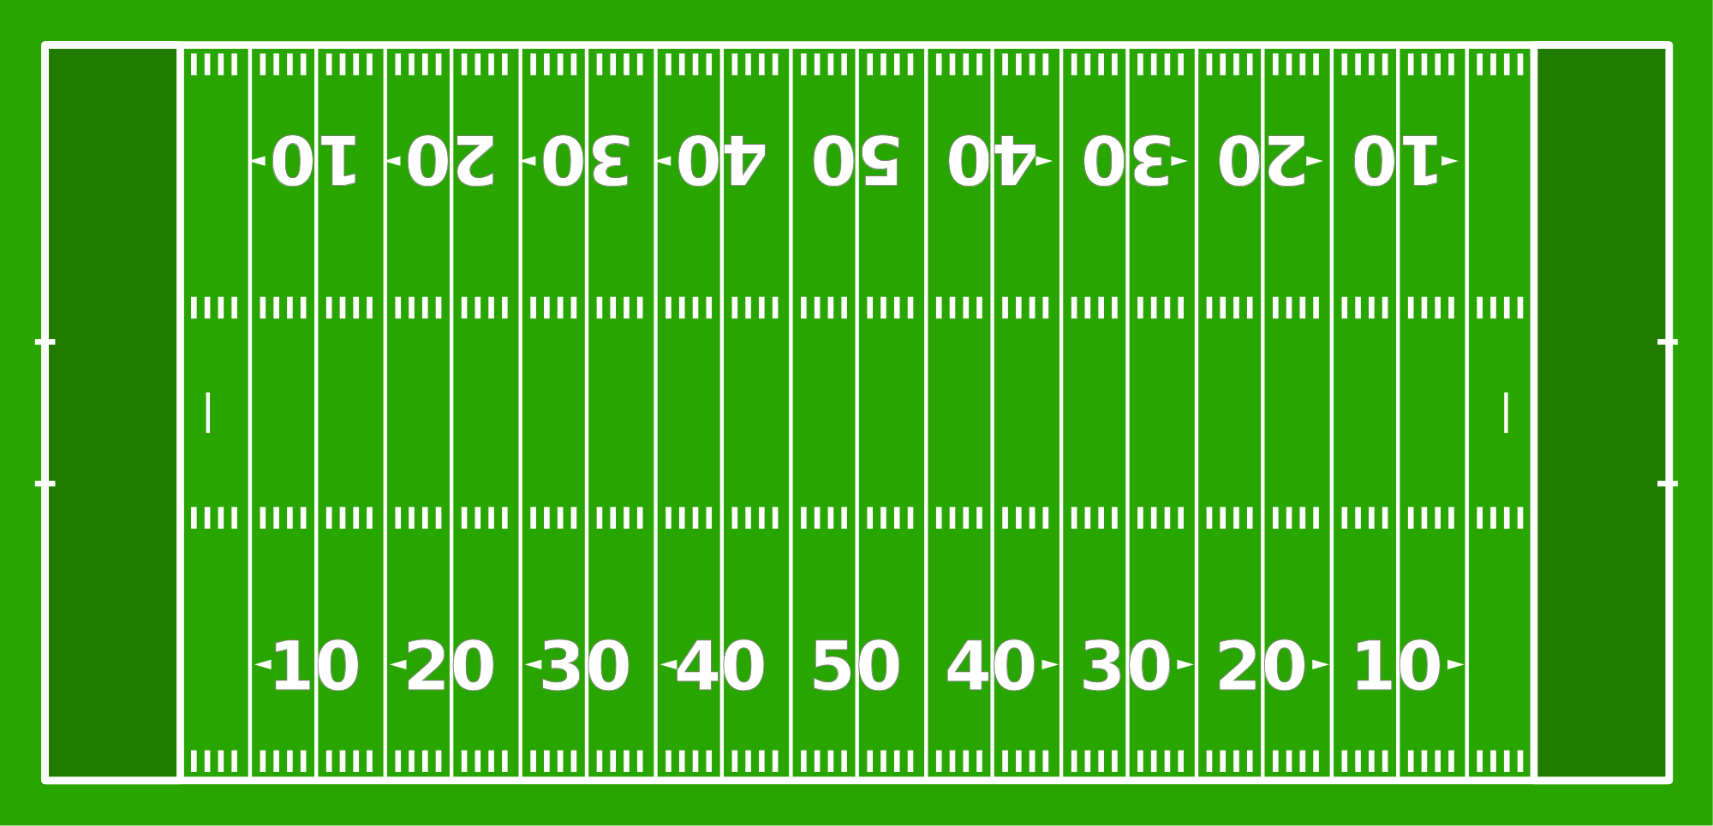
For instance, could you require participants to provide a rationale for their answer.

Interactives Activity:
EMT Basic Refresher & Body Browser
Mission. Work through the scenario to review procedures.
Step 1: Choose a scenario and go to the website.
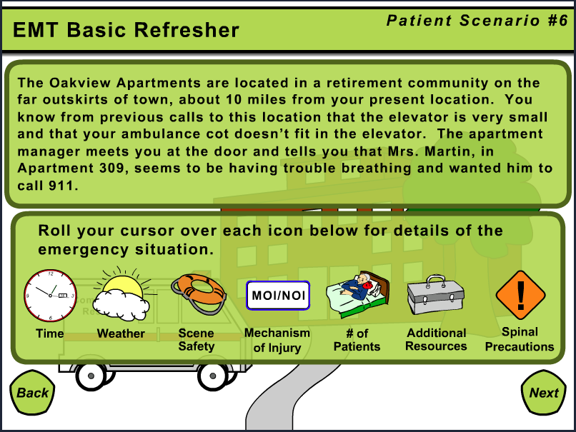
Patient Scenario #1: High School
Go to http://tinyurl.com/emsworkshop1
Patient Scenario #2: Nursing Home
Go to http://tinyurl.com/emsworkshop2
Patient Scenario #3: Home
Go to http://tinyurl.com/emsworkshop3
Patient Scenario #4: Basement Workshop
Go to http://tinyurl.com/emsworkshop4
Patient Scenario #5: Restaurant
Go to http://tinyurl.com/emsworkshop5
Patient Scenario #6: Retirement Community
Go to http://tinyurl.com/emsworkshop6
Patient Scenario #7: The Food Court
Go to http://tinyurl.com/emsworkshop7
Or, go directly to the master list at WISC-ONLINE at
http://www.wisc-online.com/Search.aspx?search=emt
Step 2: Complete the interactive as a small group.
Step 3: Discuss the pros and cons of using web-based simulations.
Step 4: Explore http://bodybrowser.googlelabs.com/
Step 5: Discuss ways that this tool could be used in your classroom.
Step 6: Discuss the pros and cons of using web-based tools in the classroom or as part of a homework assignment.

