Forms of Energy

Form Of  Kinetic Energy | Definition | Examples
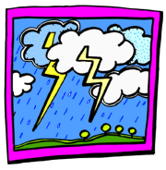 | Electrical Energy is the movement of electrical charges. Everything is made of tiny particles called atoms. Atoms are made of even smaller particles called electrons, protons, and neutrons. Applying a force can make some of the electrons move. | Electrical charges moving through a wire is called electricity. Lightning is another example of electrical energy.
 | Radiant Energy is electromagnetic energy that travels in transverse waves. | Radiant energy includes visible light, x-rays, gamma rays and radio waves. Light is one type of radiant energy. Solar energy is an example of radiant energy.
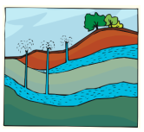 | Thermal Energy, or heat, is the internal energy in substances––the vibration and movement of the atoms and molecules within substances. | Geothermal energy is an example of thermal energy.
 | Motion Energy is the movement of objects and substances from one place to another. Objects and substances move when a force is applied according to Newton’s Laws of Motion. | Wind is an example of motion energy.
 | Sound is the movement of energy through substances in longitudinal (compression/rarefaction) waves. Sound is produced when a force causes an object or substance to vibrate––the energy is transferred through the substance in a wave.
Form Of  Potential Energy | Definition | Examples
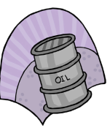 | Chemical Energy is energy stored in the bonds of atoms and molecules. It is the energy that holds these particles together. | Biomass, petroleum, natural gas, and propane are examples of stored chemical energy.
 | Stored Mechanical Energy is energy stored in objects by the application of a force. | Compressed springs and stretched rubber bands are examples of stored mechanical energy.
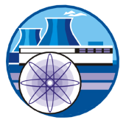 | Nuclear Energy is energy stored in the nucleus of an atom––the energy that holds the nucleus together. The energy can be released when the nuclei are combined or split apart. Nuclear power plants split the nuclei of uranium atoms in a process called fission. | The sun combines the nuclei of hydrogen atoms in a process called fusion.
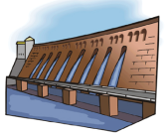 | Gravitational Energy is the energy of position or place. A rock resting at the top of a hill contains gravitational potential energy. | Hydropower, such as water in a reservoir behind a dam, is an example of gravitational potential energy.

Sample definitions from http://www.eia.doe.gov/kids/energyfacts/science/formsofenergy.html

