GIMP for Photo Editing

Download GIMP from http://www.gimp.org/
Install the software. GIMP stands for GNU Image Manipulation Program. It is open source software.

Getting Started. Click Start > Programs > GIMP. Pull down the File menu, select Open. Browse for a graphic file in Documents > My Pictures. Click Open.

Resizing a Photo. Pull down the Image menu and select Scale Image. Resize large photos to 1024x768 or 800x600 for printing. Resize photos to 150-250 pixels height for web publishing. Set the resolution to 72 pixels (dpi). Click Scale.
The photo below is 200 pixels high.
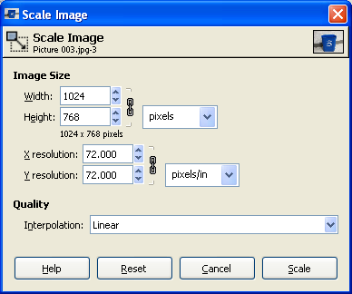
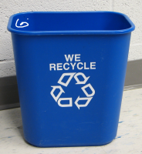

Cropping a Photo. Choose the Selection Tool from the Pull down the Tools panel. Select the area you wish to keep. Pull down the Image menu and select Crop Image.
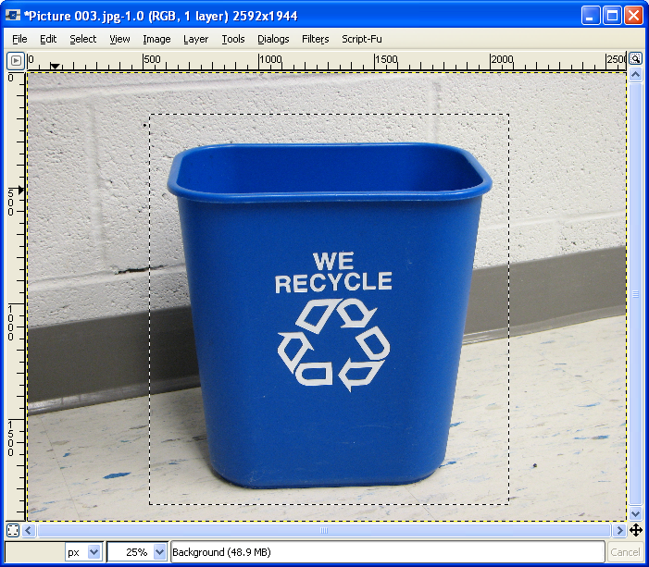

Adjusting Image Color. Pull down the Layer menu, select Colors. Notice the choices in this area. First, choose Color Balance. Use the slide bars to make minor adjustments in color. If you don’t like it, choose Reset. Within Layer>Colors, choose Brightness/Contrast and use the slide bars to make adjustments.
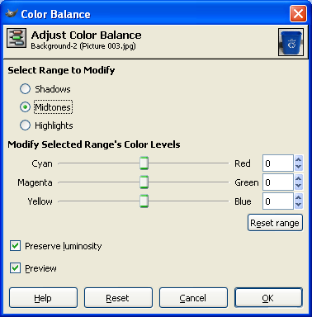

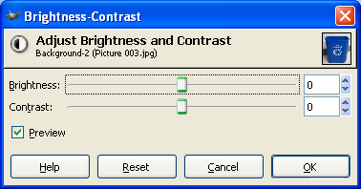

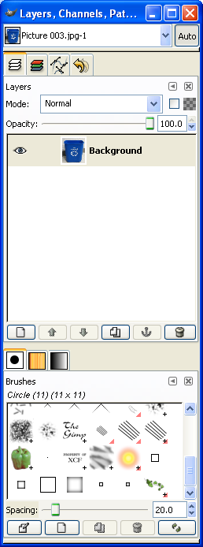
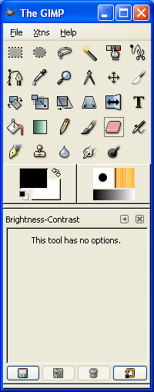
Adding Lines, Shapes, and Graphics. Select tools from the tool panel and apply them to your visual. Notice that you can change the color and brush strokes. Ideas: Take a photograph containing a “shapes in our world.” Add line s or ovals to show the shapes.

Copying a photo. If you want to copy your photo to another software package, pull down the Edit menu, select Copy to Clipboard.

Saving a photo. Pull down the File menu and select Save As. Notice the options for saving as different file types such as png.
