Photo Story 3 for Windows

Getting Started. Click Start > Programs > Photo Story 3 to open the program.
From this window you can open, edit, or read a story. Choose Begin a New Story and press Next.

Inserting Photos. You are now on the Import and Arrange Your Picture screen. Click Insert Picture… and select individual photos or groups of photos. Click OK to insert them along the timeline at the bottom of the screen. Reorder the photos by selecting the photo and using the arrows on the right side of the timeline. If you have lots of photos, you may need to use the scroll bar below the timeline. You can also drag the photos.
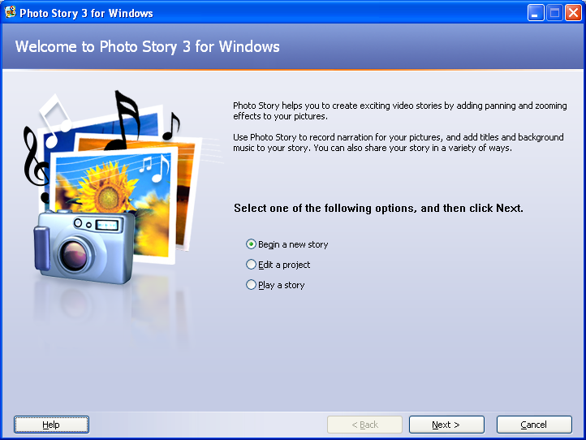
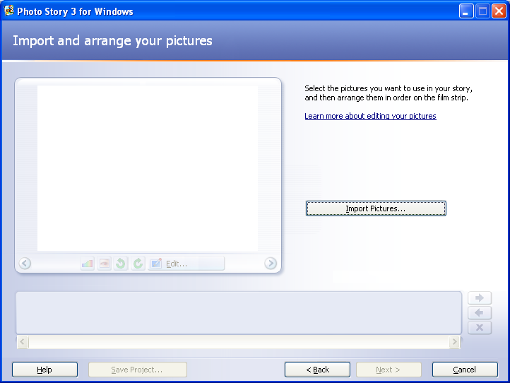
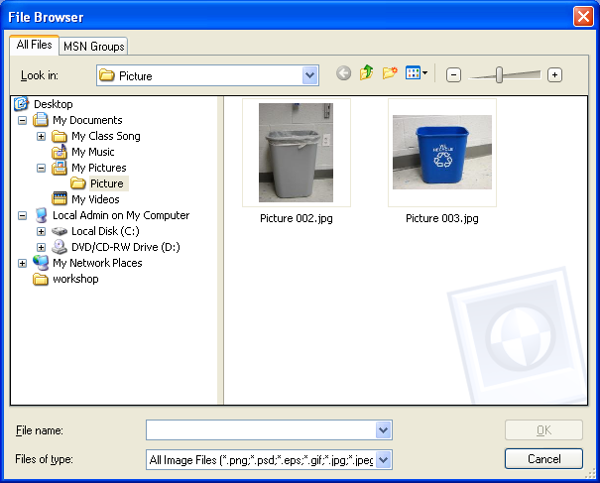

Editing Photos. Choose a photo you wish to edit. Notice the buttons below the photograph. You can adjust the color, remove red eye, rotate the photo, or crop it. When you have your images edited and in the correct order, press the Next button.
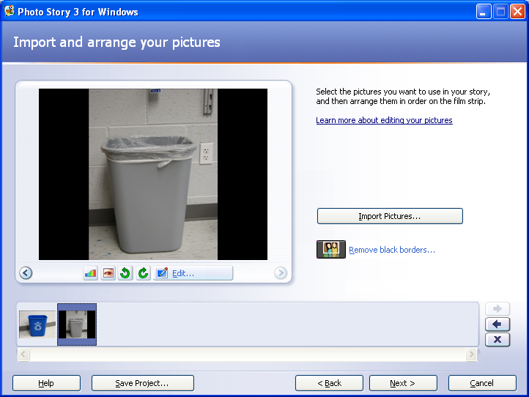
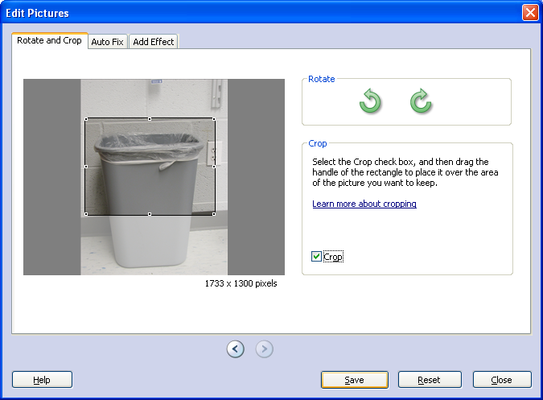

Adding Text. Select each slide and add text to the slide. You can adjust the font color and placement on the screen.
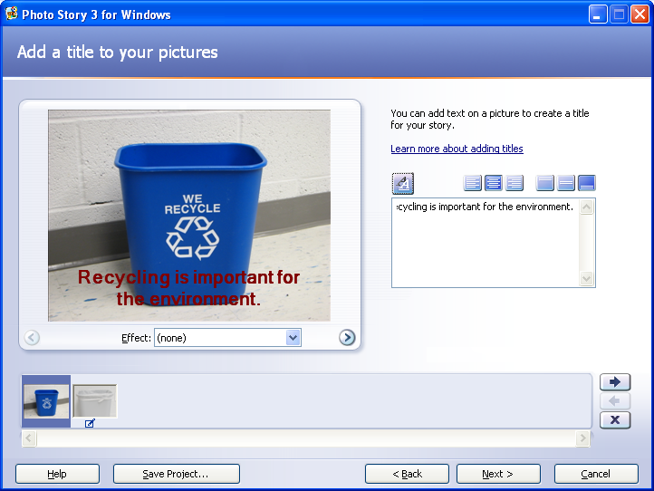
When you’ve added all the text, then press Next. You can always come back later to make changes by using the Back button.

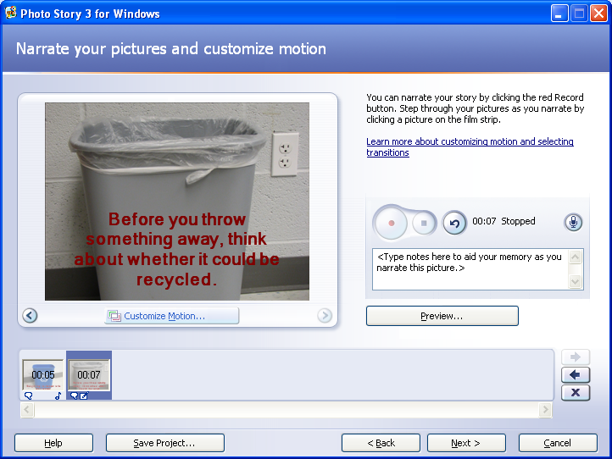
Adding Sound. You can add narration to each slide by clicking the red Record button. Press the stop button when you are done recording. Use the space below the recording area for speaking notes. Press the Next button when you’re done recording.

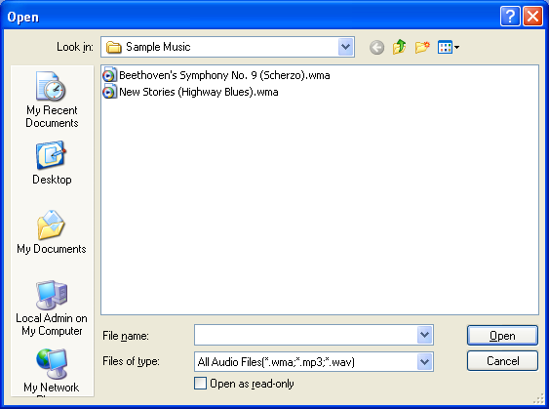
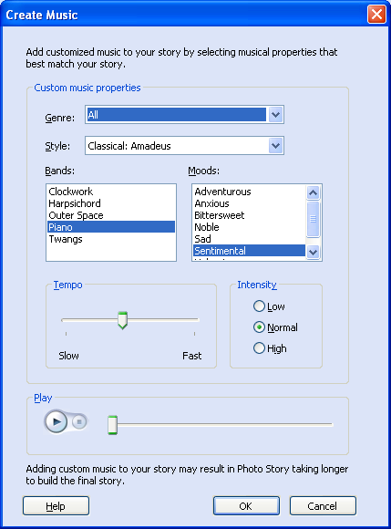
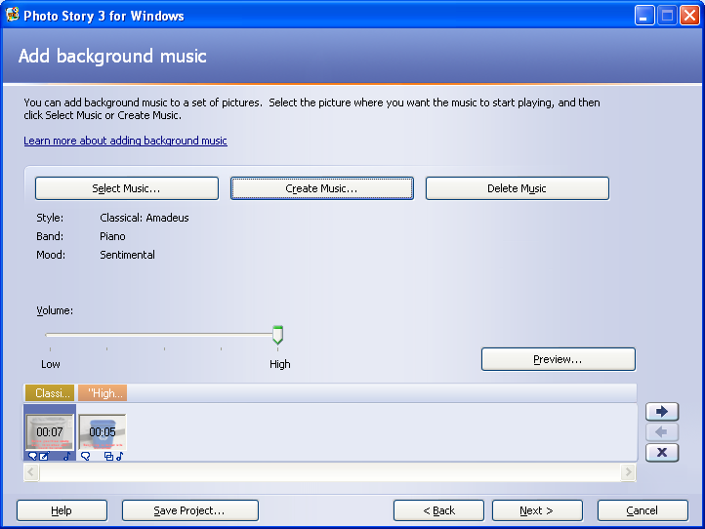
Adding Music. You should be on the Add background Music screen. If you want the music to run your entire project, select the first slide on your timeline. You can add music two ways. First, you can press Select Music, browse your music collection to find a song, then press Open. Second, you can press Create Music and use the music generator to create a production. Then, press OK.

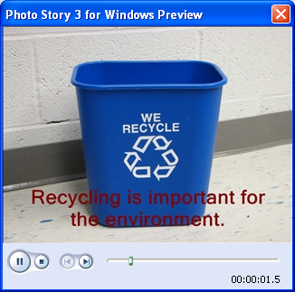
Previewing. Press Save Project to save your project. To see and hear a preview of your project, press the Preview button.

If you wish to make changes, use the Back button to go back through the sound, text, and insert screens.
Saving and Exporting Your Story. When you’re ready to save and export your project, press the Next button. You should be on the Save Your Story screen. Choose the Settings button if you wish to adjust the size of your exported project. Then click OK.
Press Browse to select a place to save your story movie. You’ll also want to save your project again. Then press Next. It will take a few seconds to build your story.
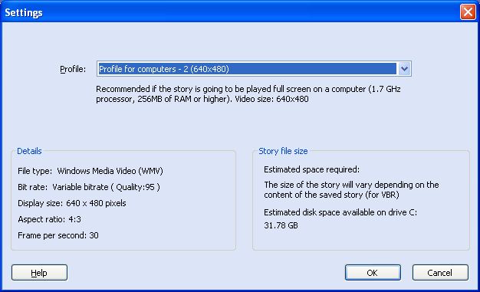
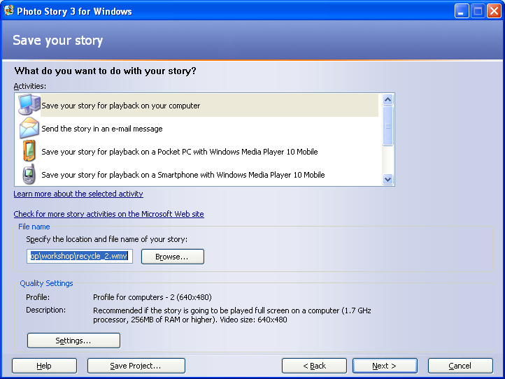

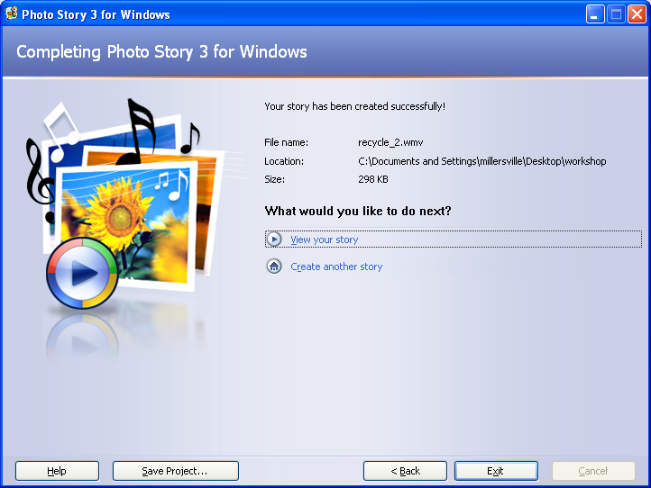
Finishing Your Project. You’re done with your project! You can view your story or create another story!

