In This Issue
In this newsletter, you’ll find out all about me and the sweet stuff that’s happening in my life.

Animals
Shopping
Friends
My Thoughts
I Can’t Think Of Anything

Animals
By Ashley

I love animals. I spend most of my day with my animals. I tell animals things I wouldn’t tell my friend become they won’t rat me out.
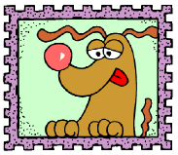

This is where more information will go. This is where more information will go. This is where more information will go. This is where more information will go.

Shopping

By Amanda

I’m obsessed about shopping. I love to find bargains. For example, I got these new jeans for $10! They were originally $50 jeans. That is so sweet.
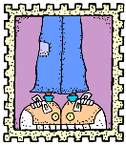

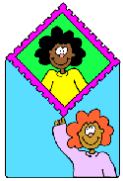
This is where more information will go. This is where more information will go. This is where more information will go. This is where more information will go.

Friends

By Ashley

My sister is my friend. You can’t trust your friends except when they’re family.

This is where more information will go. This is where more information will go. This is where more information will go. This is where more information will go. This is where more information will go. This is where more information will go. This is where more information will go. This is where more information will go.

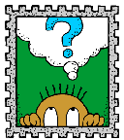
My Thoughts
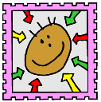
I have weird thoughts. Like, why do you park on a driveway and drive on a parkway? Why do people walk up and down escalators when they move?

This is where more information will go. This is where more information will go. This is where more information will go. This is where more information will go. This is where more information will go. This is where more information will go. This is where more information will go. This is where more information will go. This is where more information will go. This is where more information will go. This is where more information will go. This is where more information will go. This is where more information will go. This is where more information will go. This is where more information will go.

I Can’t Think of Anything
I’d like to rant about nothing. I hate it when people ask me to think of things, but then I can’t think of anything.

This is where more information will go. This is where more information will go. This is where more information will go. This is where more information will go. This is where more information will go. This is where more information will go. This is where more information will go.

Credits
The clip art came from The Big Box of Art CD.

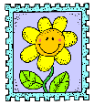
About Us

Our School
School Address
School Phone
Class Email

