Creating PowerPoint Project Starters

PowerPoint was designed as an adult tool rather than a tool for student learners, so let’s design workspaces specifically for young people.
Getting Started
Use starters that are set up with “e-paper” designed for primary or intermediate level students.
To open the starter projects:
Right-click and choose Save as Target one of the PowerPoint starters. Open this document in PowerPoint.

Adding Visuals
Locate visuals such as clip art, artwork, illustrations, and photos you wish to use in your project. Then, copy and paste visuals into your project. Consider the message and context of the visual. What’s the purpose of your visual? Does the visual need to be a realistic and accurate representation? Does the visual need to be motivating? Does it need to tell a story?
To copy a photo from the web:
Right-click on the photo and choose Copy.
Open your PowerPoint document. Right-click and choose Paste.

To edit your picture:
Right-click on the picture and choose Show Picture Toolbar.
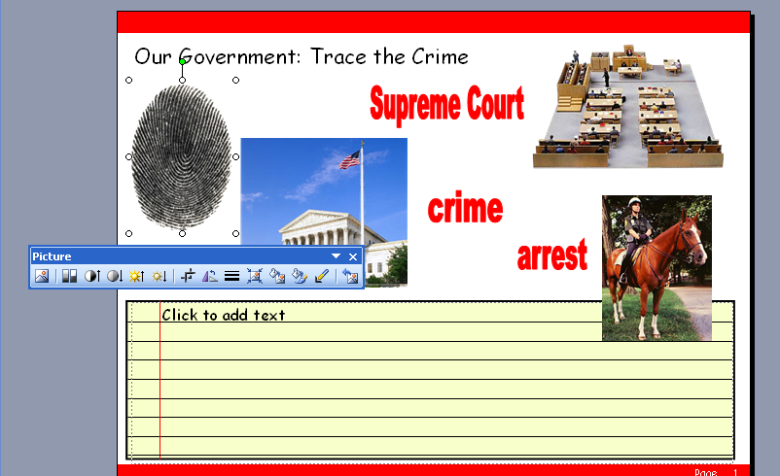
Click the Crop tool and drag from the edge of your picture to cut out parts of the picture.
Click the Set Transparent tool. Click the white space around your picture to see through the picture.

Adding a Web Address
It’s a good idea to copy the location where you found the clipart to give credit to the original source. You can paste the web address in the Speakernotes below the slide. This is particularly important if students are using projects in science or media fairs where they will be sharing with the world. If you are using websites other than clipart sites, you may wish to email the website for permission to use the visual.
To copy a website address (URL):
Click in the address area at the top of the web page. The selected area will turn blue.
Right-click and choose Copy.
Open your PowerPoint document. Click in the Speakernote area at the bottom of the screen. Right-click and choose Paste.
To make your website address active:
Click anywhere on the slide. Right-click and choose Paste.
Press the space bar after the web address to make it a hyperlink.
Right-click the hyperlink and choose Open hyperlink to go to the website.

Adding WordArt
If you want students to move words around on the screen or match words and picture, use WordArt.
To add WordArt:
Click on the WordArt button on the Drawing Toolbar.

Choose a shape for your WordArt. I’d recommend sticking to the first option because the others can be difficult to read.
Type your text and click OK.
Use the paint bucket to fill your words with color.
Drag them to place them on your screen.
If you want students to check their answers, you can put WordArt answers under the pictures.
To send pictures or WordArt in front or behind other objects:
Right-click on the graphic, choose Order, select Bring to Front, Send to Back, Bring Forward, or Send Backward.

Adding Speakernotes
The Speakernotes provide some directions about editing the page. You can delete these directions and add your own directions for students.

Adding Sounds
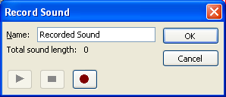
Sounds can enhance your project in many ways. You can record your directions or provide audio prompts. You may want students to create their own sounds such as narration, definitions, or character voices. It’s helpful to use the Speakernotes to type your directions. Then, record them.
To record sound:
Pull down the Insert menu, choose Movies & Sounds, select Record Sound.
Be sure to give the sound a name by removing the words Recorded Sound and typing your own word.
Click the red dot record button to record your voice. Click the stop button when you’re done. Click play to hear your voice. Click OK to save your voice. A sound icon will appear on the screen. Drag it to the upper left hand corner of the page or wherever you wish.

Adding More Pages
You may want to create multiple pages for your projects.
To add another screen:
Pull down the Insert menu and choose New Slide. Notice that the Speakernotes and graphics are gone, but the writing space is still available.

Changing the Master Page
You may find a project that requires a different “look.” For example, you may wish to change the colors or placement of the text area. You’ll need to change the Master Slide. This will change every page in your project, so be careful.
To edit the Master Slide:
Pull down the View menu, select Master, and Slide Master.
Change the colors of graphic elements or adjust the placement of the text boxes.
If you change the fonts, the lines won’t match, so you may need to adjust these.

Creating a Student Version
When you’re done with the project, you’ll want to save a READ ONLY version for the students to use. Then, they won’t save over your version. Instead, they’ll rename it and put it in their own folder.
To set a file to READ ONLY:
Exit PowerPoint. Find the file on your hard drive.
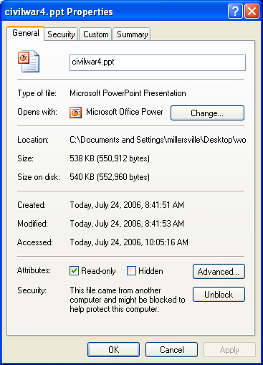
Right-click on the file and choose Properties. Check Read-only.

Use the following ideas to get started repurposing the starters.

